Your contact person:

Philipp Schulte-Derne
Marketing and internet

Telephone +49 7022 702-129
Fax +49 7022 702-101
Philipp.schulte-derne@holzher.com
Total word count: 941
Characters (incl. blank spaces): 6111

February 2019

Date

PRESS RELEASE

LIGNA 2019

Automation with high customer benefits
Digitization has been changing our working world at an incredible pace for years. From the beginning, HOLZ-HER focused not only on increasing efficiency for the customer, as a matter of course, but also on a high degree of transparency of production processes and particularly user-friendly new applications. “Plug and play” is the number one requirement for all new developments. HOLZ-HER will present its solutions and products at LIGNA 2019 with live demonstrations to prove that this is possible.

Automation Pro
The next big step in automated production at HOLZ-HER is called Automation Pro. This concept is the logical continuation of the innovative NEXTEC solutions. It interconnects the entire production process from the STORE-MASTER panel storage system to finished pieces of furniture across the entire HOLZ-HER machine inventory, even in large interior fitting companies and in industrial production. Our own, pre-installed solution defines the production route. The HOLZ-HER Warehouse has a key function here. Released orders are transmitted to the HOLZ-HER Warehouse for management, and processing instructions are distributed to the relevant HOLZ-HER machines such as saws, nesting machines and edge banders. New HOLZ-HER machines can of course also be integrated.
NEXTEC 4.0
With the NEXTEC 4.0, HOLZ-HER has taken the NEXTEC workshop of the future one step further. The new NEXTEC 4.0 office software module is a standard feature of the Push, Automatic and Lift Edition machine versions. For the customer, this means that the software and database for production control as well as the CabinetSelect software are already pre-installed. Another component of the package is the HOLZ-HER Warehouse designed for managing orders directly at the machine or in the office. The integration into the customer’s company network can be performed easily. Upon request, an additional module serves as an interface to the HOLZ-HER edge banders.

EVOLUTION series
Efficient production is hardly conceivable without a CNC processing center, even in smaller carpentry businesses. And there’s room for it even with the minimum of space: With its EVOLUTION series, HOLZ-HER offers complete vertical processing with a small footprint. The processing capabilities of the vertical CNC processing centers from the EVOLUTION series are almost unlimited.

Even with the new EVOLUTION 7402 4mat you can benefit from four-sided formatting. Even the standard version of the drilling and formatting center is equipped with a powerful 5.6 kW spindle, making it ideal for cut-outs and pockets. A fully equipped drilling head (15 spindles) incl. a grooving saw are available to cover all drilling requirements. Optionally, the system can be equipped with even stronger spindles and larger drilling heads.

The 7405 4mat can do even more with the integrated 6-position tool changer: For example milling, cut-outs, engraving, profiling, furniture joints. New is the ingenious door package “Doors Ready”. It consists of a specially developed angular gear for lock mortises and a lock mortise cutting unit. The package allows for complete processing of door leaves up to 70 mm thick.

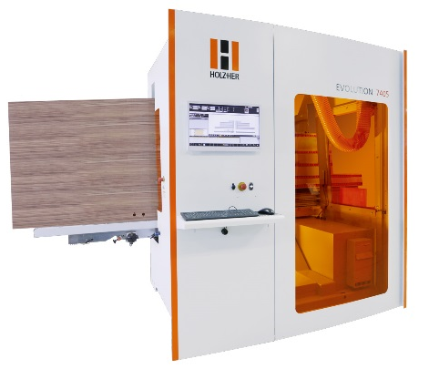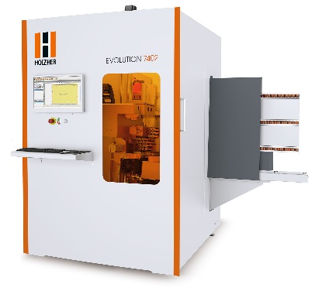

TECTRA 6120
With its new appearance in dark grey, the HOLZ-HER TECTRA 6120 pressure beam saw matches the design of the HOLZ-HER machines perfectly. It offers a maximum of performance and quality for perfect panel splitting. The standard electrical adjustment of the 2.2 kW scoring saw saves a lot of time and offers a precise adjustment of the scoring saw blade. A bidirectional grooving device is another standard feature. The TECTRA variants range from the Classic or Power versions for manual loading, through the Lift variant with lifting table to the Dynamic, which is operated via the STORE-MASTER storage system. In HOLZ-HER machines, the collets are float mounted on linear guides, preventing pressure marks on the material. The 7.7 kW main saw motor can handle jobs at top speeds of up to 130 m/min. The EasyPlan software allows parts to be optimized and moved, and it even supports the representation of furniture fronts.

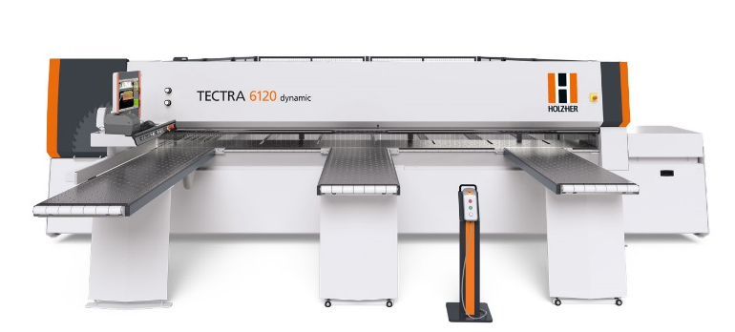

RETURN-MASTER 5920
Even in smaller workshops, automation is becoming increasingly important in order to remain competitive and to operate profitably. The RETURN-MASTER is a component for automated edge processing, whether in series production or for single-item batches. The return unit from HOLZ-HER enables efficient single-operator use for increased productivity and maximum flexibility. This makes the RETURN-MASTER 5920 the perfect supplement to all HOLZ-HER edge banders. In comparison with many competing products, the RETURN-MASTER with its 2 tons of dead weight is characterized by a particularly stable design. Further quality features are the tilting air pad table and the certified safety package for a safe workplace. With its high-quality drives and guides, the RETURN-MASTER is very low-maintenance and extremely durable.
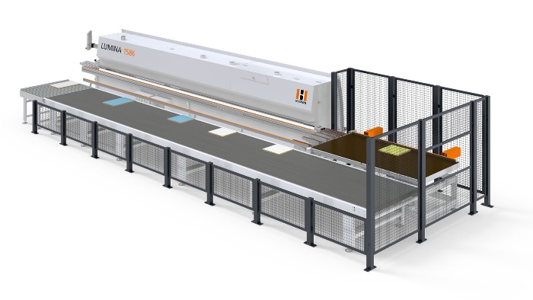

LUMINA 1596
The edge banders of the LUMINA series stand for perfect zero joint technology with laser edging and PUR. The LUMINA 1596 4.0 edition convinces with further highlights. The NC servo axes of the latest generation ensure lightning-fast changeover to different applications and guarantee a high level of repetition precision, accuracy, and longevity.

Another hot topic for efficient edge banding is “Equipping in the gap”. This allows different processes to be carried out simultaneously on the edge bander. For example, the corner copying unit can be switched on intelligently without having to idle the machine for set-up.

The new intelligent operator guidance allows an even more intuitive adjustment of all cutting and scraping operations. The operator can perceive visually at any time which corrections are being made in which direction. The values entered at the control for horizontal and vertical tool adjustment are automatically converted to the actual axis values in the background and can be re-applied with a high level of precision at any time. Test workpieces are now almost a thing of the past.

